FIRAS PERFUME — Brand & Landing Page Design Audit
Updated visual analysis based on actual product, packaging and logo references

1. Brand & Industry Overview
FIRAS Perfume is a fragrance / perfumery e-commerce brand operating in the alternative or “inspired-by” perfume niche, with strong Arabic/Oud and attar heritage cues. The brand is made in Palestine, with customer contact via WhatsApp/Instagram (@FERAS_BARFAN) routed through a Qatar number — indicating a Gulf/Middle East customer base.
- Primary category: Beauty & Personal Care → Fragrances → Alternative / Inspired Perfumes & Attars
- Secondary category: Arabic/Oud perfumery and concentrated oil attars (Misk line)
- Business model: Direct-to-consumer e-commerce — online showcase, ordering and sales
- Brand identity: A polished crest-style logo (crown + circular monogram “F” + floral flourish) with the wordmark “FIRAS / PERFUME” in a refined serif — signals classic, regal luxury rather than edgy/modern minimalism

2. Actual Packaging & Bottle Reference
The client's photos reveal a consistent two-line system. Both bottle designs share the same agate/marble swirl pattern (gold swirls on a dark base) with a flat oval cap and gold collar — only the base glass colour and box colour change by gender.
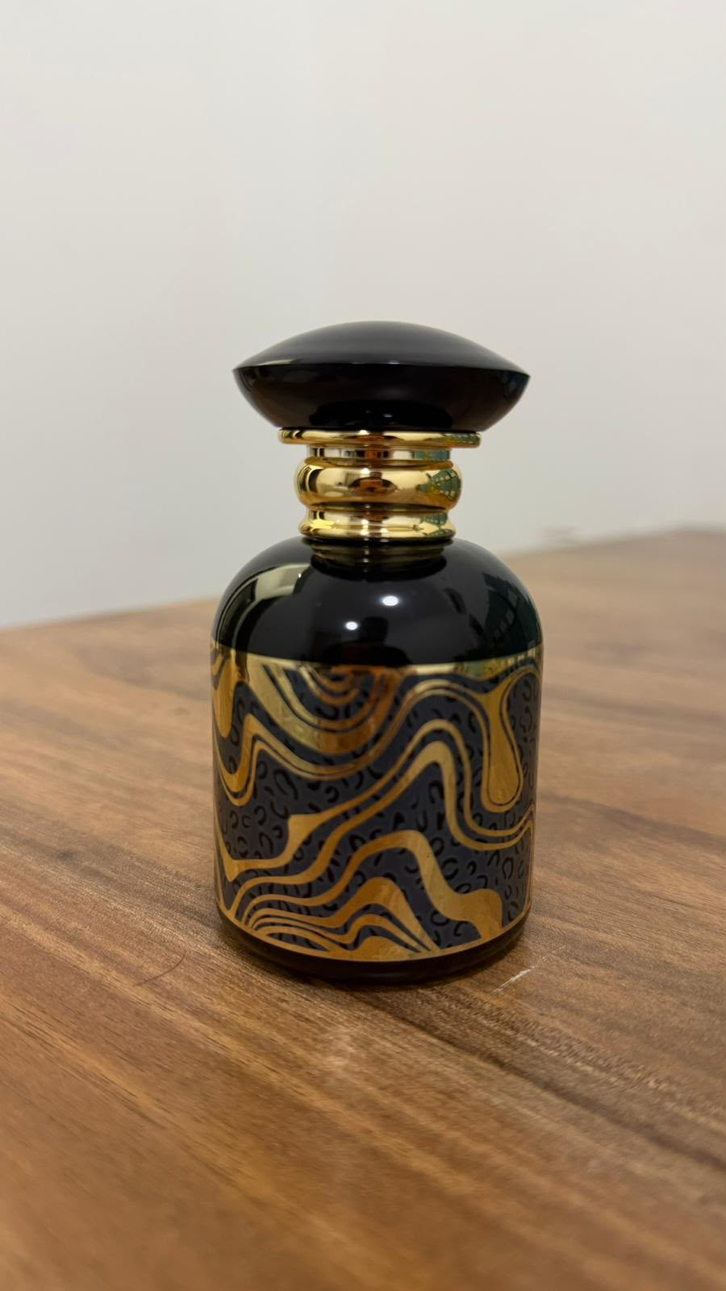  Men's Bottle — Black & Gold Swirl | 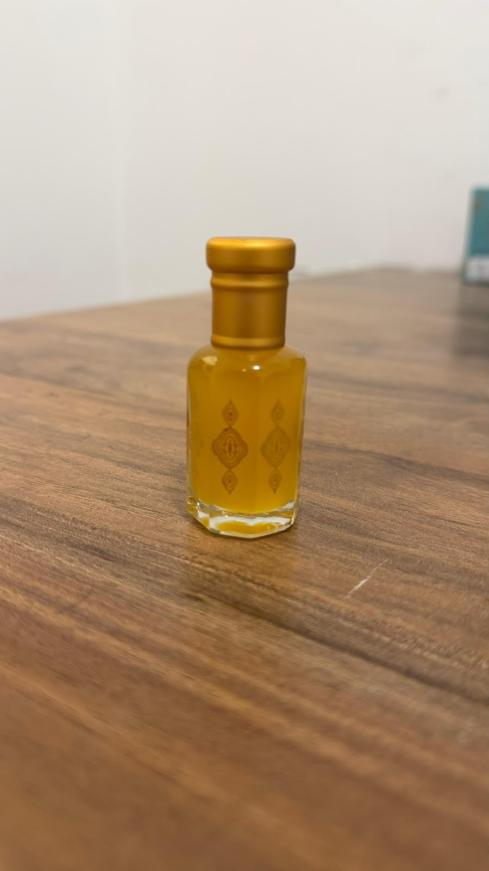  Women's Bottle — Green & Gold Swirl
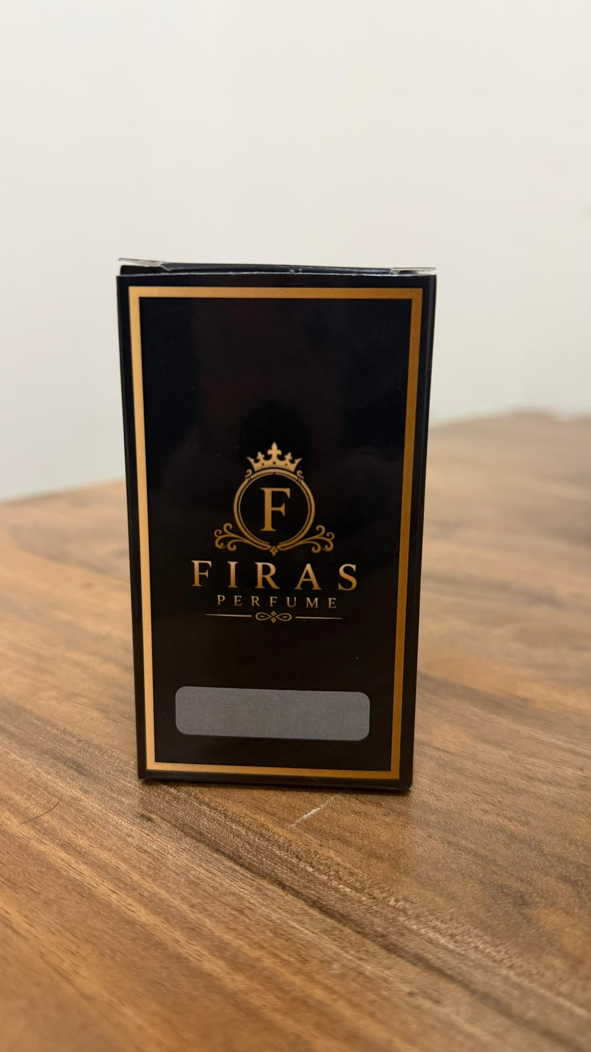  Men's Box — Black & Gold Crest | 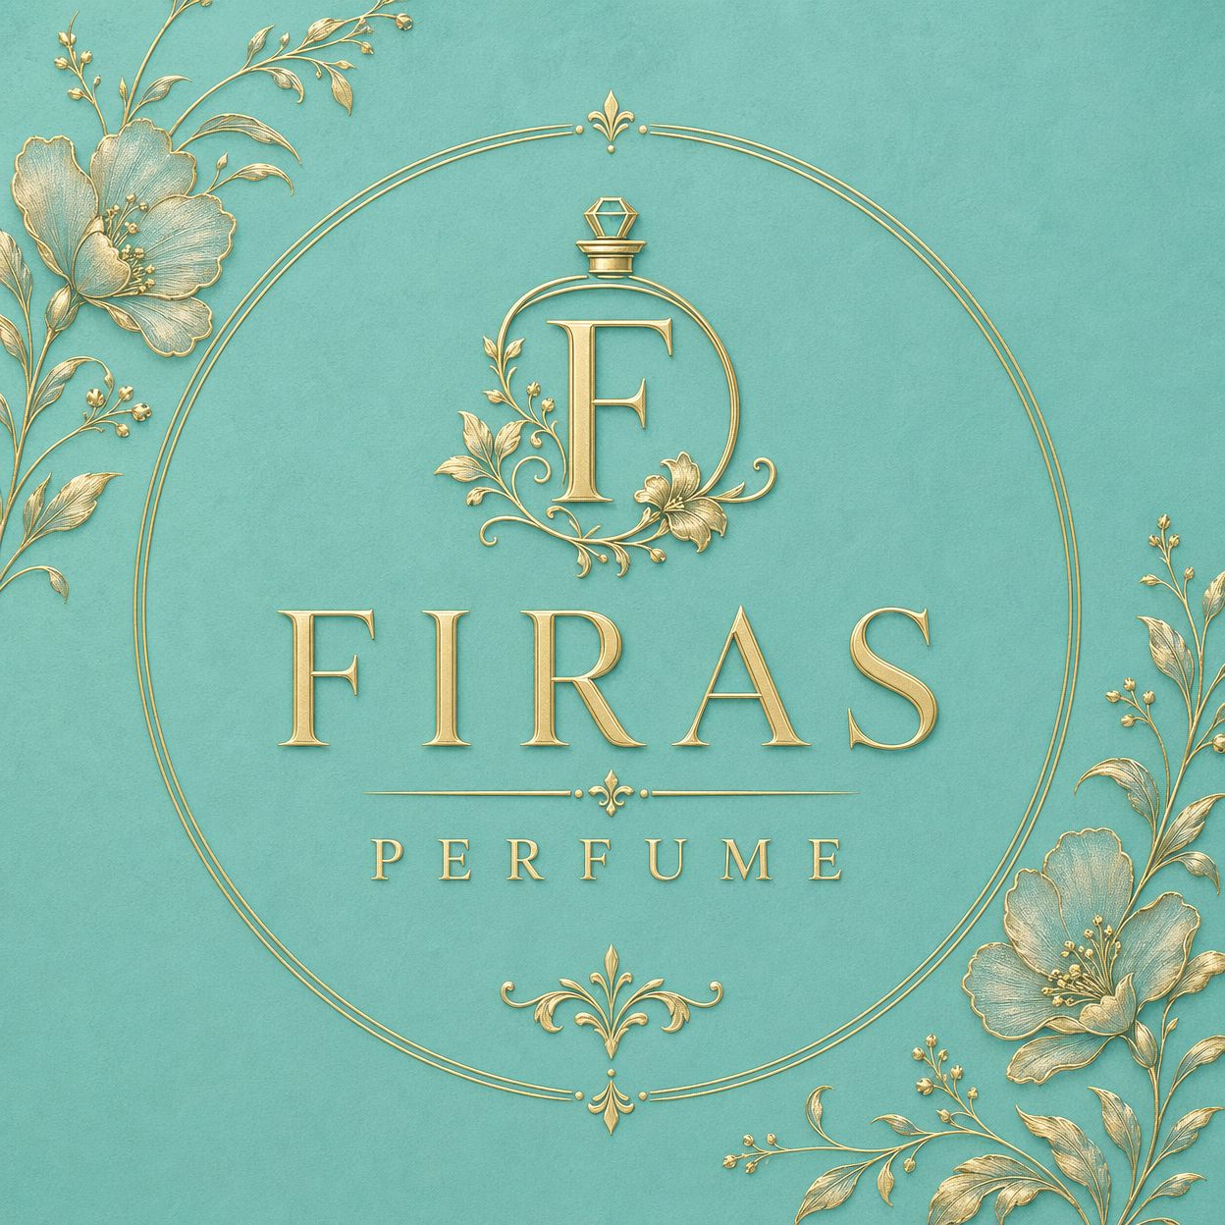  Women's Box — Teal Floral

Additional line: a small hexagonal white-and-gold attar bottle and a clear glass roll-on with gold oil were also shown — likely for the Misk Al Tahara and Misk Oud Al Karam concentrated oils, which can be presented as a “premium oil / attar” sub-collection on the site.

3. Logo Reference
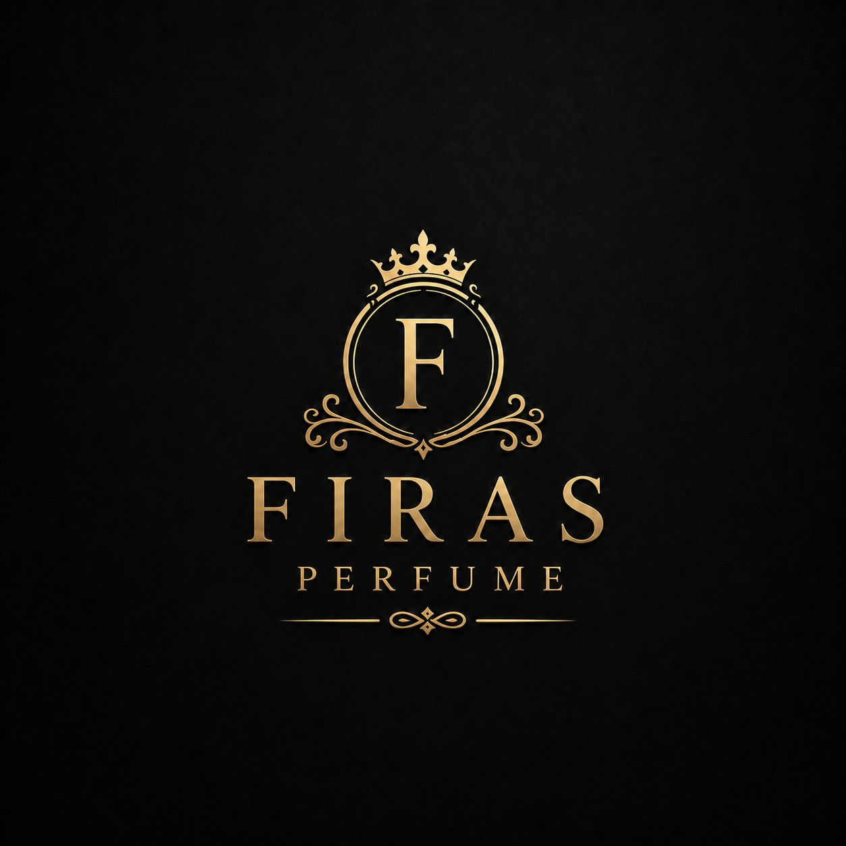  Primary Logo — Gold on Black | 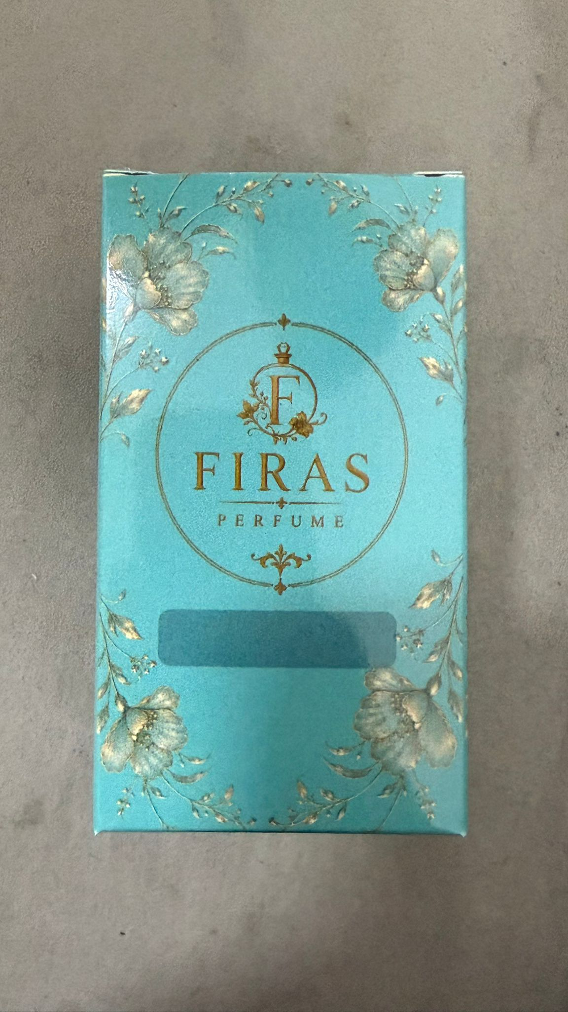  Logo Lockup — Gold on Teal Floral

Logo notes: ornate gold crest (crown above a circular monogram “F” with floral scrollwork), serif wordmark “FIRAS”, small-caps “PERFUME” subtitle with a decorative flourish divider. This crest treatment is the brand's strongest asset and should anchor the site's hero/header area — works equally well reversed (gold-on-black) or on the teal floral background.

4. Product Catalogue Summary

Men's Collection (Black & gold swirl bottle / Black & gold crest box)
- G-Armani
- Imperial Valley
- Creed Aventus
- Oud Cady
- Misk Oud Al Karam

Women's Collection (Green & gold swirl bottle / Teal floral box)
- Good Girl
- Ajmal Lamsa
- Chanel No. 5
- Gucci Flora
- Lancôme La Vie Est Belle
- Misk Al Tahara
Since both bottle designs are shared per gender, one retouched master image per gender can be reused for every SKU — ideal for a uniform, grid-based product gallery.

5. Revised Brand Colour Palette
Updated from the actual packaging: the men's line is black + antique gold on a swirling agate pattern; the women's line uses the same gold swirl on a deep bottle-green, paired with a soft turquoise/teal floral box. Together these suggest a palette built around gold as the unifying luxury accent, with black and teal as the two collection-defining tones.
Swatch | Hex | Role | Usage Notes
 | #1A1A1A | Onyx Black | Primary — men's collection, header/nav, dark sections
 | #B8860B | Antique Gold | Core accent — logo, CTAs, borders, icons (matches foil on bottles/boxes)
 | #1F3D2B | Bottle Green | Secondary — women's bottle accents, deep section backgrounds
 | #8FCFC8 | Soft Teal | Women's collection — box colour, section backgrounds, badges
 | #F7F2E8 | Ivory / Cream | Dominant background — keeps the page light and premium
 | #8A8A8A | Warm Grey | Body text on light backgrounds, secondary UI

Usage logic: Ivory/Cream as the main canvas; Onyx Black panels and gold-on-black hero for the overall brand/Men's pages; Soft Teal sections with gold accents for the Women's collection; Antique Gold consistently for buttons, dividers, the logo crest, and price tags to tie both lines together.

6. Suggested Typography
Headings / Logo Display | A refined high-contrast serif matching the logo's “FIRAS” wordmark (e.g. Playfair Display, Cormorant Garamond, or similar) — reinforces the existing crest identity
Body / UI Text | A clean geometric sans-serif (e.g. Montserrat, Poppins) for product descriptions, navigation and checkout flows
Accent / Labels | Letter-spaced uppercase sans-serif for tags such as “MEN” / “WOMEN” / “INSPIRED BY” / “ATTAR COLLECTION”, mirroring the small-caps “PERFUME” in the logo

7. Dribbble & Behance Search Keywords
Use the following keyword sets when searching Dribbble and Behance for landing page design inspiration. Combine 2–3 terms per search for best results.

Core / Industry Keywords
- perfume website design
- fragrance landing page
- perfume e-commerce UI
- luxury beauty website design
- attar oil brand website
- scent brand website concept

Style / Aesthetic Keywords
- black gold luxury website
- gold foil branding website
- dark mode luxury ecommerce
- editorial product landing page
- crest logo luxury brand website
- teal and gold website design

Layout / Section Keywords
- hero banner product website
- product grid ecommerce design
- men vs women collection landing page
- shopify perfume store concept
- product page UI design perfume
- brand story section website

Regional / Niche Keywords
- oud perfume branding
- arabic perfume packaging website
- attar fragrance website design
- middle eastern luxury brand website
- royal crest logo perfume

8. Photography & Asset Recommendations
- Reshoot or retouch both master bottles (black/gold and green/gold) on a dark gradient or marble surface with soft rim lighting to highlight the agate swirl pattern and gold collar/cap
- Produce one labeled variant per SKU by swapping only the name area on the box/bottle, since both lines share a single bottle and box design
- Add subtle reflection, soft shadow and a light bloom behind the gold cap for a premium studio feel
- Prepare a square (1:1) crop for product grid cards and a tall (4:5 or 3:4) crop for hero/banner use
- Use the gold-on-black and gold-on-teal logo lockups as hero overlays or section dividers to reinforce brand recognition

9. Next Steps
- Confirm the gold / black / teal palette direction with the client before high-fidelity mockup
- Retouch the two master bottle photos and the attar/oil bottles, then produce labeled variants for each SKU
- Build wireframe: Home (hero with crest logo, Men/Women collection split, bestsellers, Misk/attar spotlight, brand story – Made in Palestine, newsletter), Shop/Category, Product Detail, Cart/Checkout
- Source 3–5 reference shots from Dribbble/Behance using the keyword sets above to align on final visual style

